**DR. ROHINI PRASAD SHETTY**

**Designation:** Director of Sports & Physical Education.

**Qualifications:** B.Com, B.P.Ed, NSNIS (Kabaddi), M.P.Ed, Ph.D. (Physical Education)

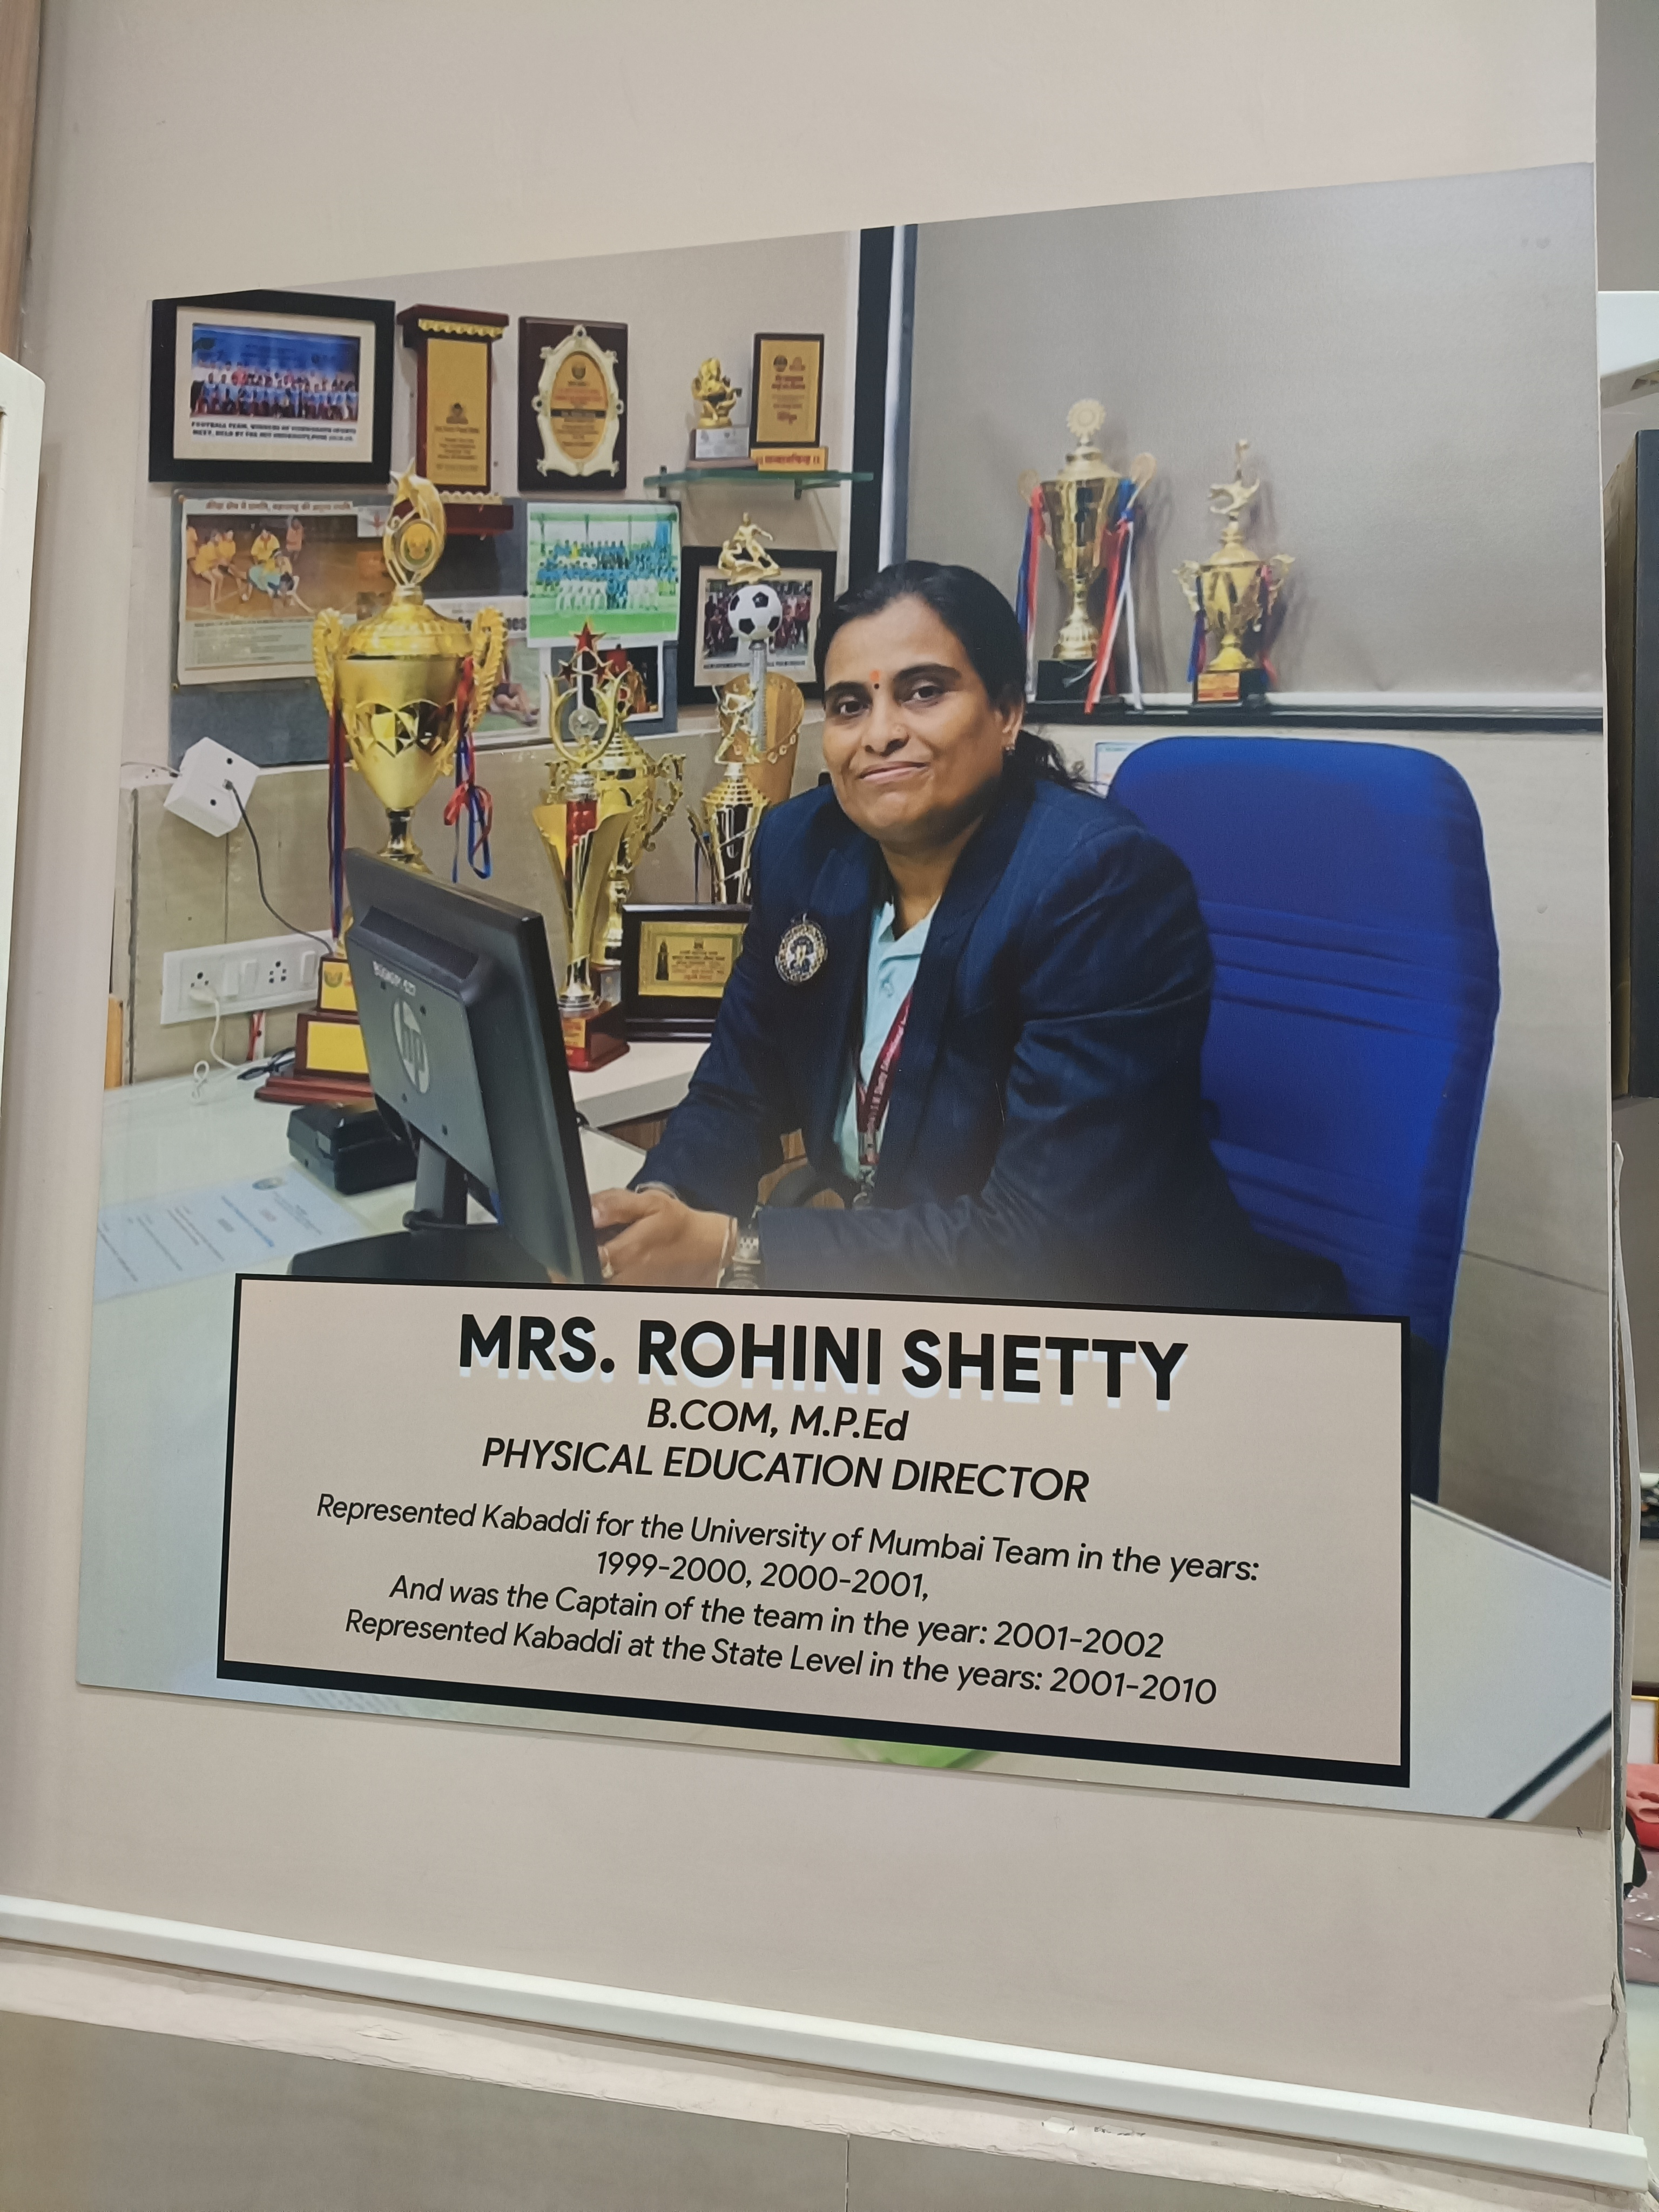

**1. University Representation**:

Represented the University of Mumbai Kabaddi Team in the years:

• 1999–2000

• 2000–2001

**2. Leadership Role:**

Served as Captain of the University of Mumbai Kabaddi Team in:

• 2001–2002

Under her captainship, the University of Mumbai Girls’ Kabaddi Team won First Place that same year.

**3. State-Level Representation:**

Represented Kabaddi at the State Level from:

• 2001 to 2010

**4. Professional Expertise & Academic Contributions:**

• Holds a NSNIS Certification in Kabaddi.

• Earned a Ph.D. in Physical Education.

• Attended workshops in the field of Physical Education.

• Published research papers in the domain of Physical Education.

**5. Service to Institution:**

• Serving with exemplary dedication and leadership as the Director of Sports & Physical Education at Bunts Sangha's S. M. Shetty College of Science, Commerce and Management Studies (Autonomous), Powai.

**6. Selection & Coaching Roles**

• Committee Member – University of Mumbai Zone II.

• Selection Committee Member – Kabaddi (Boys & Girls), University of Mumbai Zone II (2022 onwards).

• Coach-cum-Manager – Kabaddi (Boys & Girls), University of Mumbai Zone II (2022 onwards)

• Selection Committee Member – University of Mumbai Kabaddi Girls’ Team (2021 & 2024).

• Manager – University of Mumbai Kabaddi Girls’ Team (2024).

• Coach-cum-Manager – University of Mumbai Ashwamedh Kabaddi Girls’ Team (2024)

- Team won Gold Medal.

Under her guidance, the Kabaddi teams from Zone II have consistently secured championships or runner-up positions in the University of Mumbai tournaments from 2022 onwards.